Steps before rebuilding EC2 instance:

- Make sure reports folder is backed up somewhere
- Make sure you have the latest DB snapshot

Migration Steps:

After app startes:
1. Create role "ROLE_SWITCH_USER", if it does not already exists.
2.

PreMigration Steps:

- Make sure config.groovy has proper value for basePath variable.
- Make sure datSource.groovy has proper variables for the database.
- Build war file
- Upload war file on AWS
- Build the environment if not already exists - with instance type t1.micro

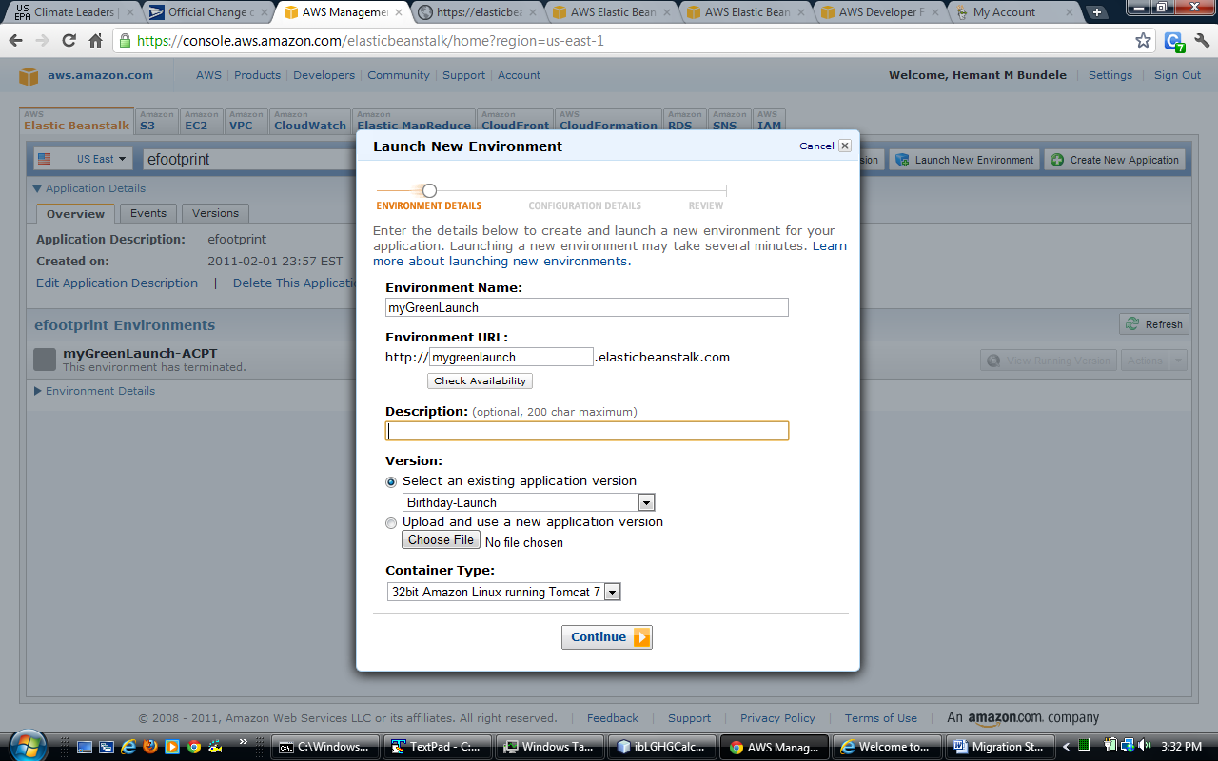

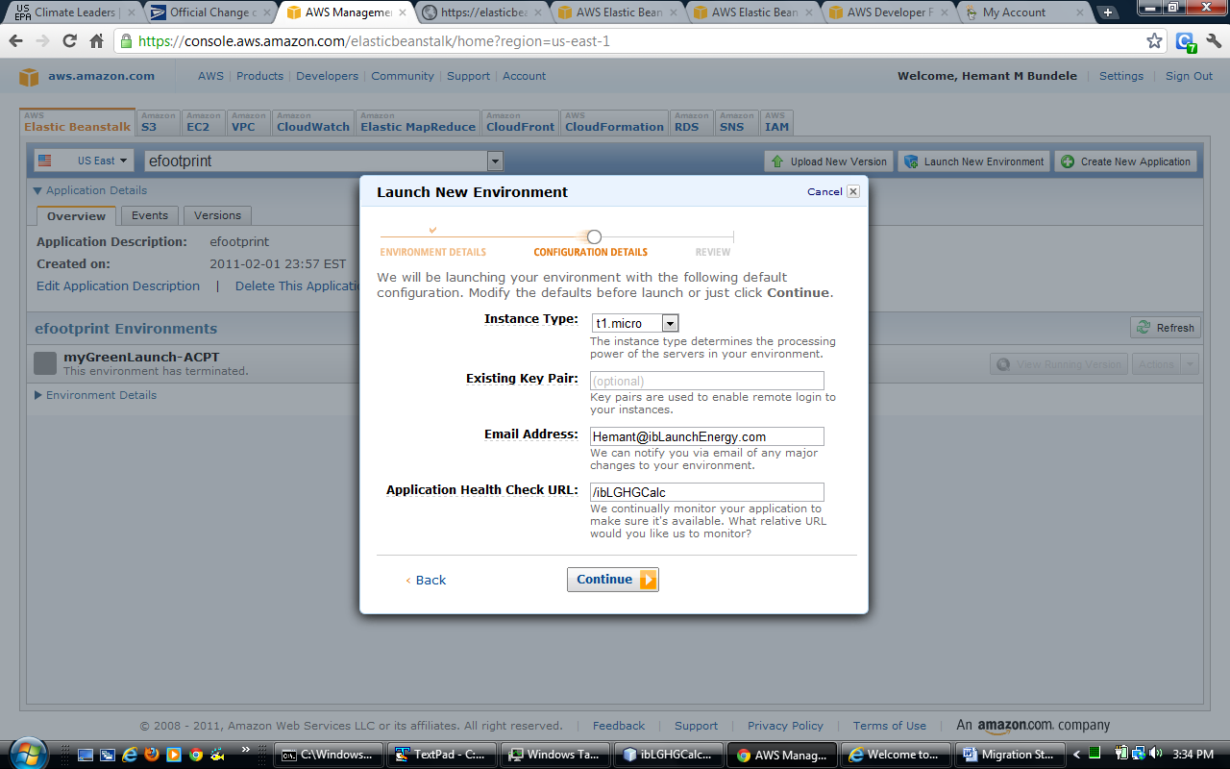

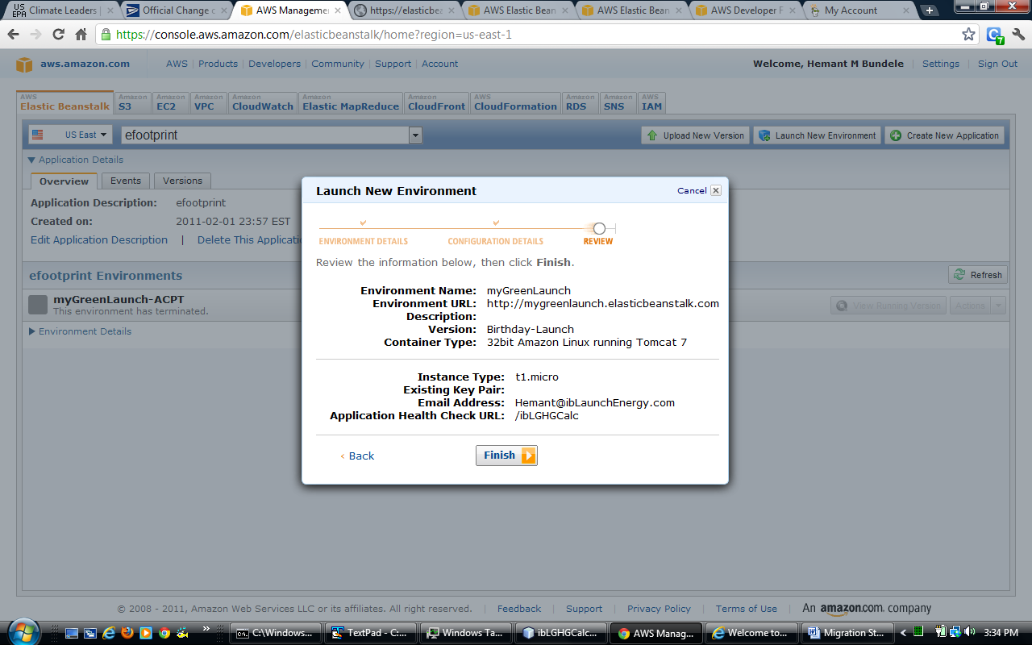

4. Launch or create DB instance:

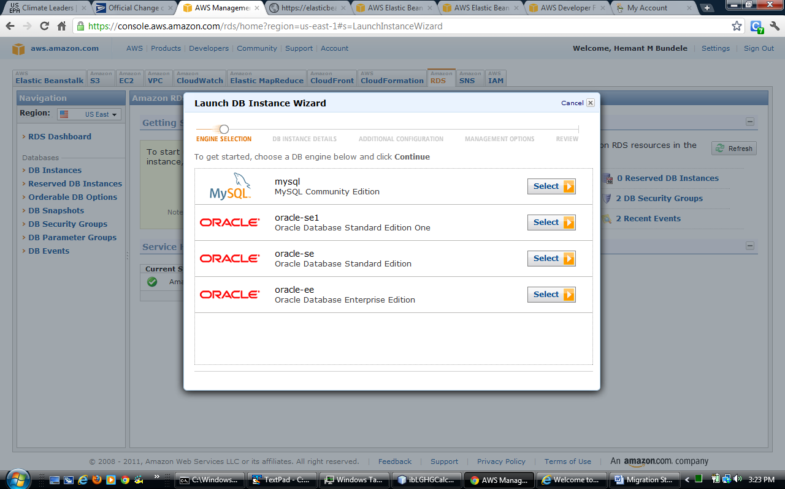

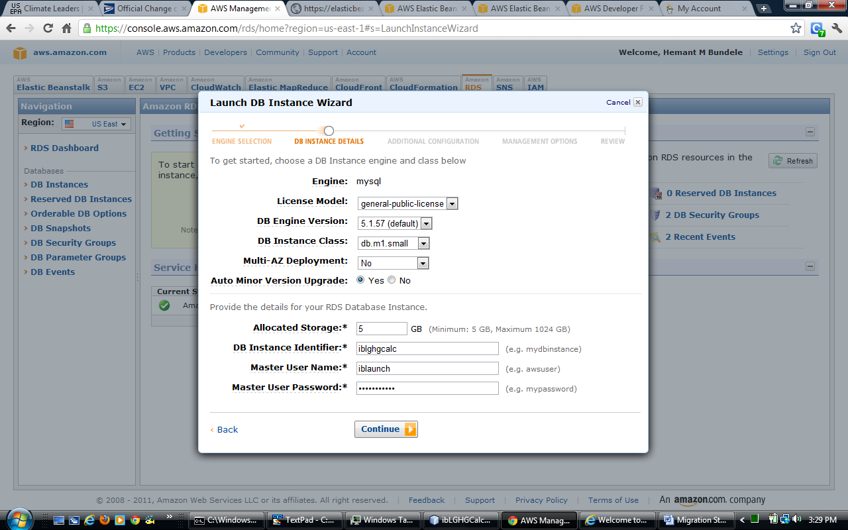

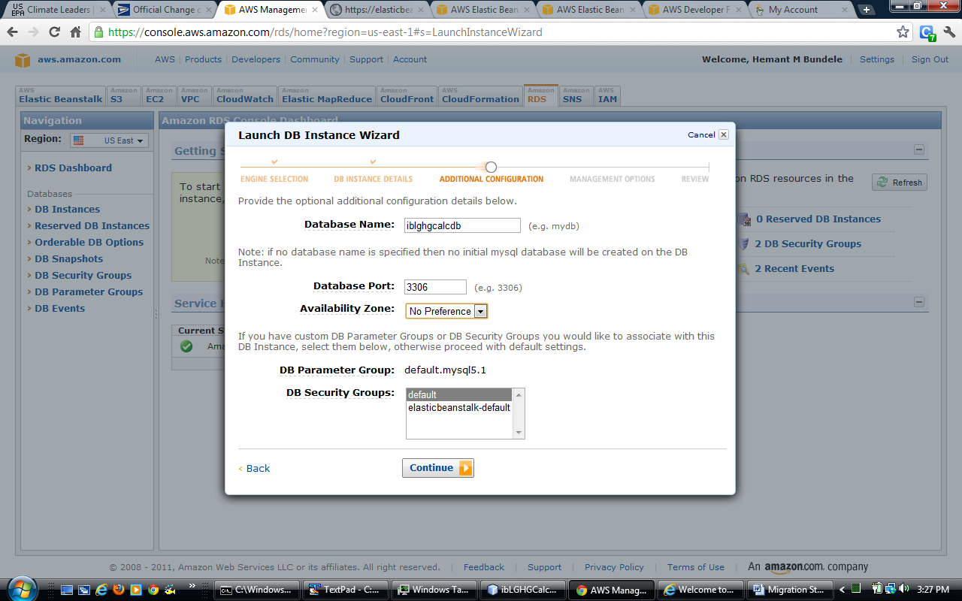

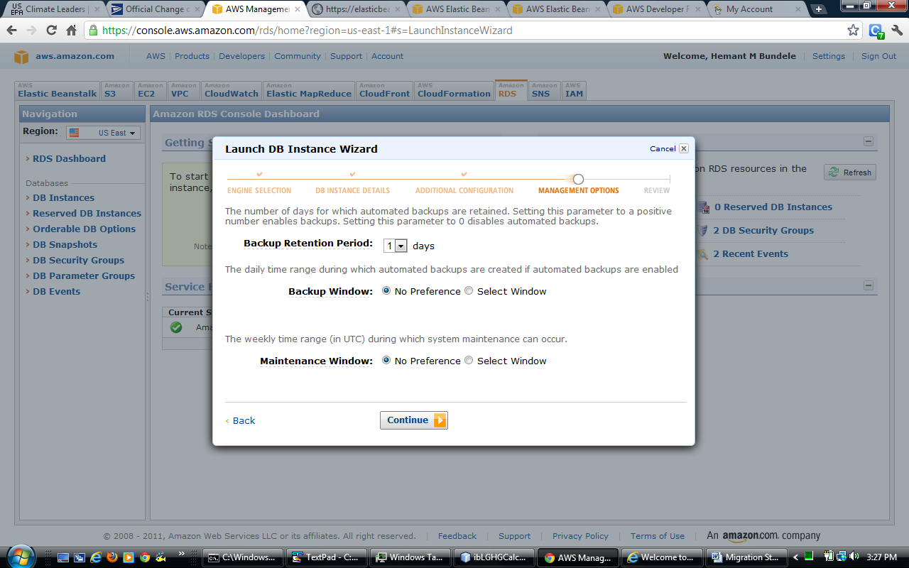

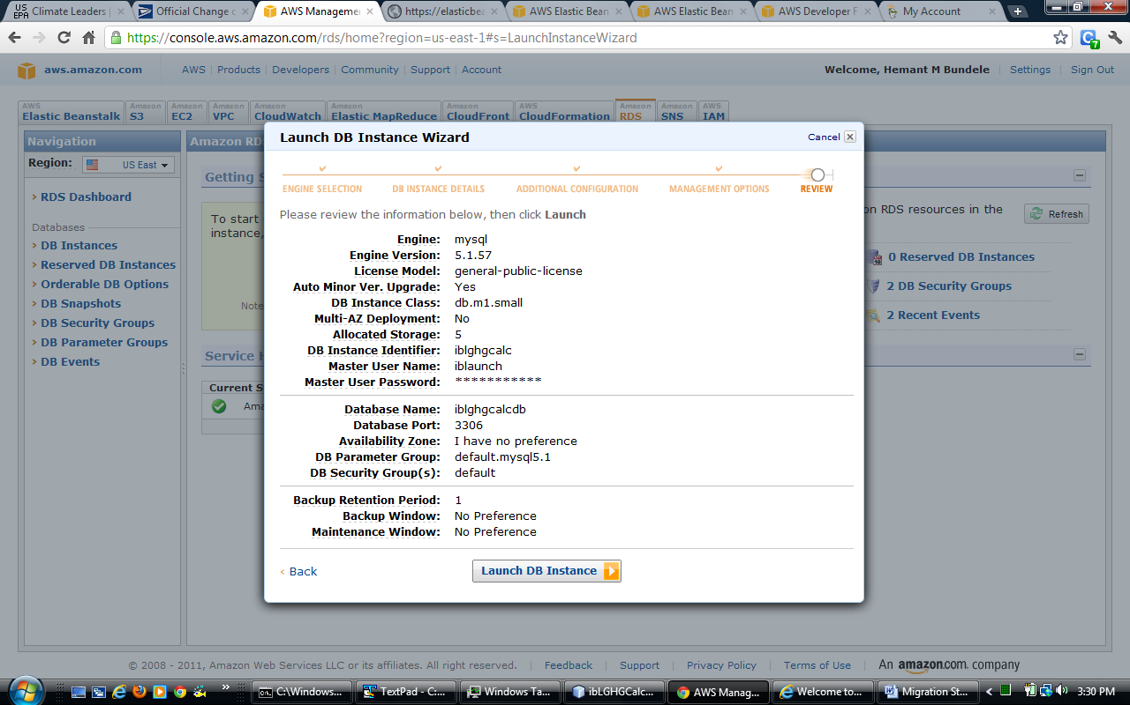

5. Make sure EC2 secirty group is added to DB Security group. Know which one lynix env on EC2 is using. I wasted 4 hours figuring this out. Use following links as reference:

http://docs.amazonwebservices.com/AmazonRDS/latest/UserGuide/index.html?USER_WorkingWithSecurityGroups.html

https://forums.aws.amazon.com/thread.jspa?messageID=161973&#161973

https://forums.aws.amazon.com/thread.jspa?threadID=58951&tstart=25

6. While giving access to MySQL from NetBeans make sure you give access via CIDR/IP in “default” security group.

Check ip address of current machine using : http://www.ipchicken.com/

7. Github remote host password: ibLaunch

Jasper report jar files in lib folder:
http://java.dzone.com/articles/java-reporting-part-2
To set up working environment we need to download JasperReport jar file from the following URL:http://sourceforge.net/project/showfiles.php?group_id=36382&package_id=28579
And add the following jars to your project classpath:
- jasperreports-2.0.4.jar ----????
- commons-digester-1.7.jar
- commons-collections-2.1.jar (commons-collections.jar)
- commons-logging-1.0.2.jar
- commons-beanutils.jar
- iText-2.0.7.jar (used infor PDF exporting)

Putty for AWS EC2:

http://docs.amazonwebservices.com/AmazonEC2/gsg/2006-06-26/putty.html

http://docs.amazonwebservices.com/AmazonEC2/gsg/2006-06-26/running-an-instance.html

https://forums.aws.amazon.com/thread.jspa?threadID=58872

- Make sure provide EC2 key pair to elastic bean stalk in the configuration, when instance starts.
- for example, “2011-07-06” was provided in existing key pair

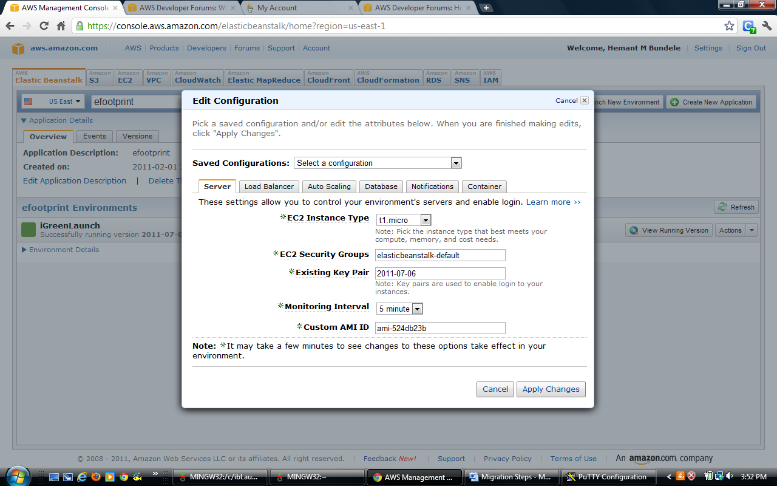

3. Download keypair to your local machine
4. Make sure use puttyKeyGen to convert keypair to be used with putty
5. You can also use git console to connect using:

ssh -i 2011-07-06.pem ec2-user@ec2-107-20-0-151.compute-1.amazonaws.com

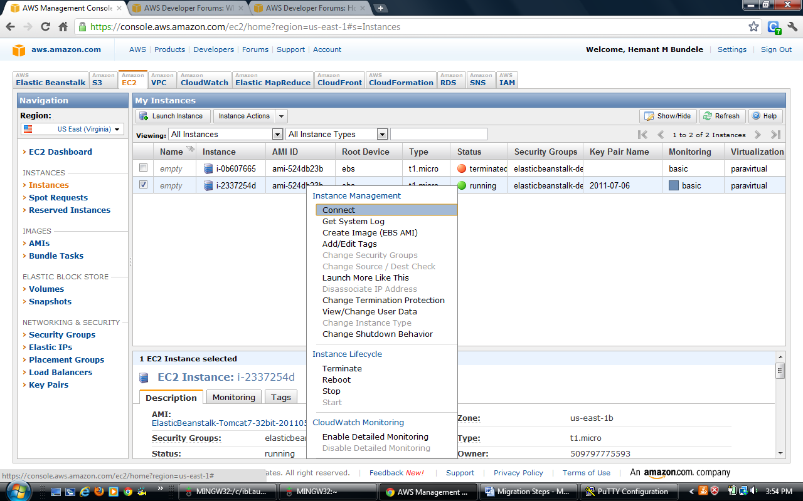

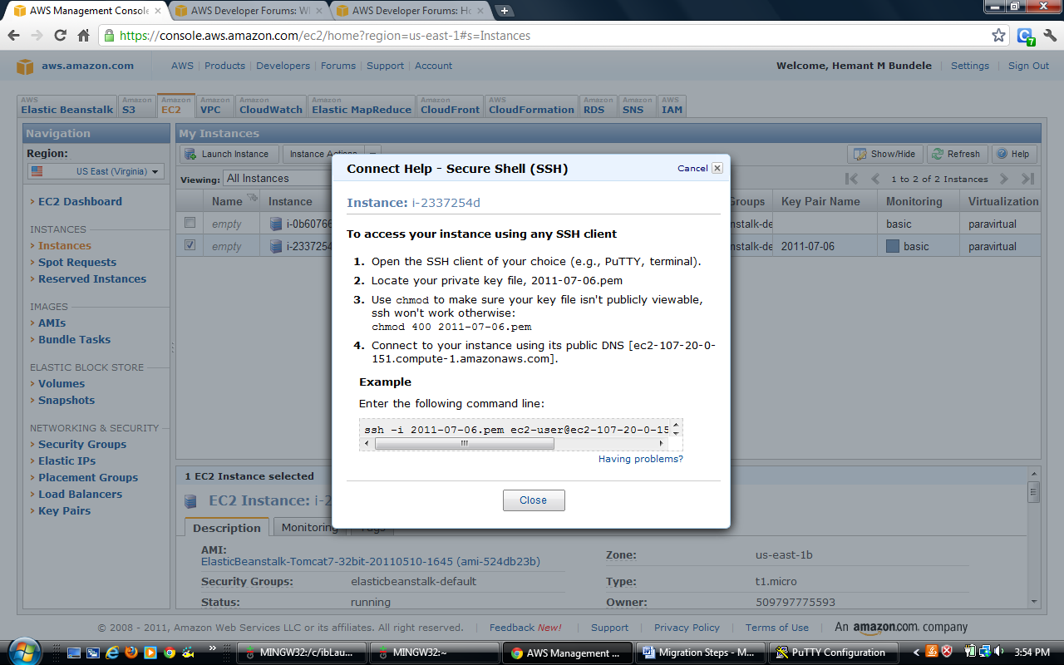

Find files:

Do “sudo su” on command prompt, otherwise you will get lot of permission denied

http://www.ling.ohio-state.edu/~kyoon/tts/unix-help/unix-find-command-examples.htm

find . -name "rc.conf" –print

find . -name “Report-4-2011-07-06-12-27-48.pdf” –print

Where is the app installed:
/opt/tomcat7/webapps/ROOT

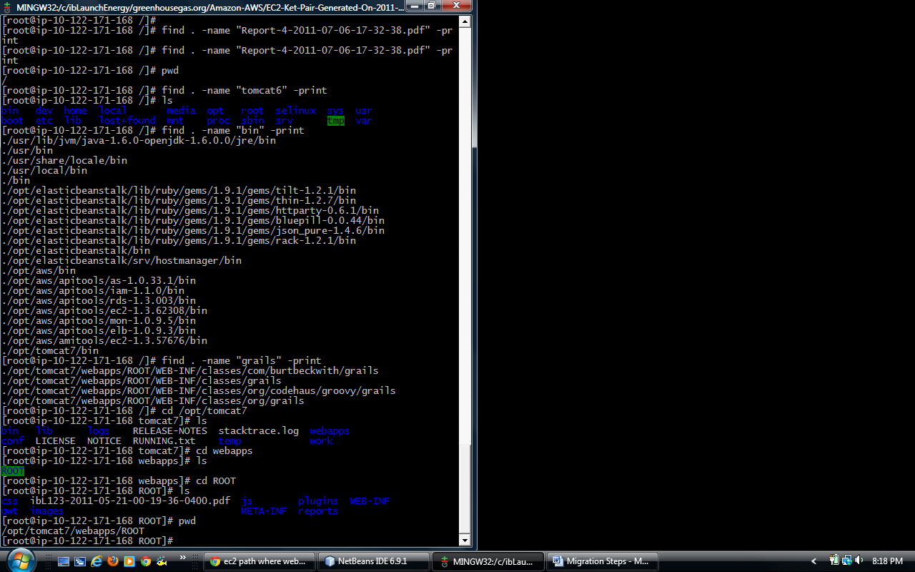

======================================================
Where log files:
/opt/tomcat7/logs

Use gunzip to uzip .gz files

http://www.gzip.org/

======================================================

Error tracking example:

[root@ip-10-122-171-168 logs]# cat catalina.out
params: -----[_componentId:isc_ListGrid_1, _operationType:fetch, currentInventor
yBeginDate:2005-01-01, organizationName:iGreenLaunchDemo, pointOfContact:iGreen
Launch, lastUpdated:2011-07-06, currentInventoryEndDate:2005-12-31, _endRow:75,
_textMatchStyle:substring, isc_metaDataPrefix:_, id:4, _sortBy:-lastUpdated, isc
_dataFormat:xml, _startRow:0, dateCreated:2011-07-06, programType:US EPA, _dataS
ource:emissionsSummaryDS, action:list, controller:emissionsSummary]
parameters[_componentId:isc_ListGrid_2, _operationType:add, isc_dataFormat:xml,
organizationName:iGreenLaunchDemo, emissionsEndDate:1969-12-31, emissionsBeginDa
te:1969-12-31, programType:US EPA, _dataSource:emissionsSummaryDS, isc_metaDataP
refix:_, action:calculateEmissionsSummary, controller:emissionsSummary]
parameters.emissionsBeginDate : 1969-12-31
parameters.emissionsEndDate : 1969-12-31
parameters.programType : US EPA
theEmissionsSummary.fireSuppressantEmissions : 0.0
theEmissionsSummary.purchasedElectricityEmissions : 0.0
theEmissionsSummary.purchasedSteamEmissions : 0.0
theEmissionsSummary.wasteStreamCombustionEmissions : 0.0
theEmissionsSummary.productTransportByWaterAirEmissions : 0.0
theEmissionsSummary.totalEmissions : 0.0
theEmissionsSummary.programType : US EPA
----------Base Directory-----------null
Report Generated!!!!!!
apply [report_organization_id:4, report_begin_date:Wed Dec 31 00:00:00 UTC 1969,
report_end_date:Wed Dec 31 00:00:00 UTC 1969, SUBREPORT_DIR:/reports/ghgReport,
REPORT_LOCALE:en_US]
2011-07-07 00:47:23,179 ["http-bio-8080"-exec-41] ERROR ibLGHGCalc.EmissionsSumm
aryService - java.lang.ClassCastException: cannot assign instance of net.sf.jas
perreports.engine.base.JRBaseStaticText to field net.sf.jasperreports.engine.bas
e.JRBaseParagraph.paragraphContainer of type net.sf.jasperreports.engine.JRParag
raphContainer in instance of net.sf.jasperreports.engine.base.JRBaseParagraph
Report not Generated!

Important link about using https:

https://forums.aws.amazon.com/thread.jspa?messageID=222032&#222032

Installing sunJDK on AWS:

https://forums.aws.amazon.com/thread.jspa?threadID=62270

Fonts installation:

https://forums.aws.amazon.com/thread.jspa?threadID=62535

sudo yum install liberation-fonts

sudo vi /etc/tomcat6/tomcat6.conf
add following
JAVA_OPTS="$JAVA_OPTS -server -Djava.awt.headless=true"

